26 - Romantics – What I Like About You
First chord Original key: Fsus4 or Esus4 Us: Dsus4
YAM: WURLI (RH) KORG:PICK for solo in F (LH) Sound check

[Intro, Verse & Chorus]
8 bars solo guitar
D G | C G [4x]

[Guitar solo 1] KORG:PICK
F | C | F | G | G | A | A | A
Be ready to resume riff!

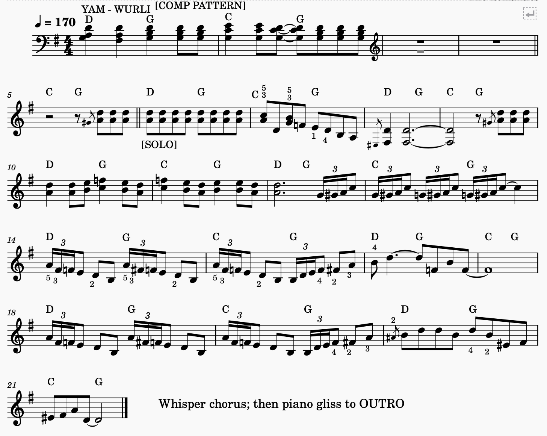
[Harmonica solo] → [Piano solo]

